

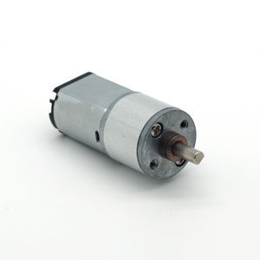

#### 16mm DC gear motor series

**SPECIFICATIONS:**

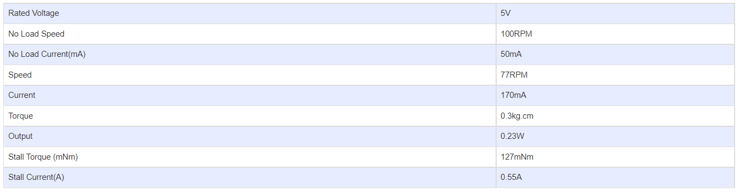

**GEARBOX OPTIONS:**

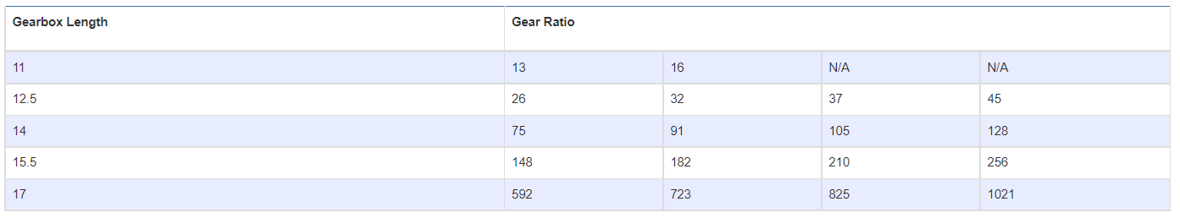

**SUBMODELS:**

*The following are common submodels for the LDO-16GM030 series.*

